IED HW5

Kismet Crossdale, Hayden Fuller, Jameson Giannattasio

Step 1:

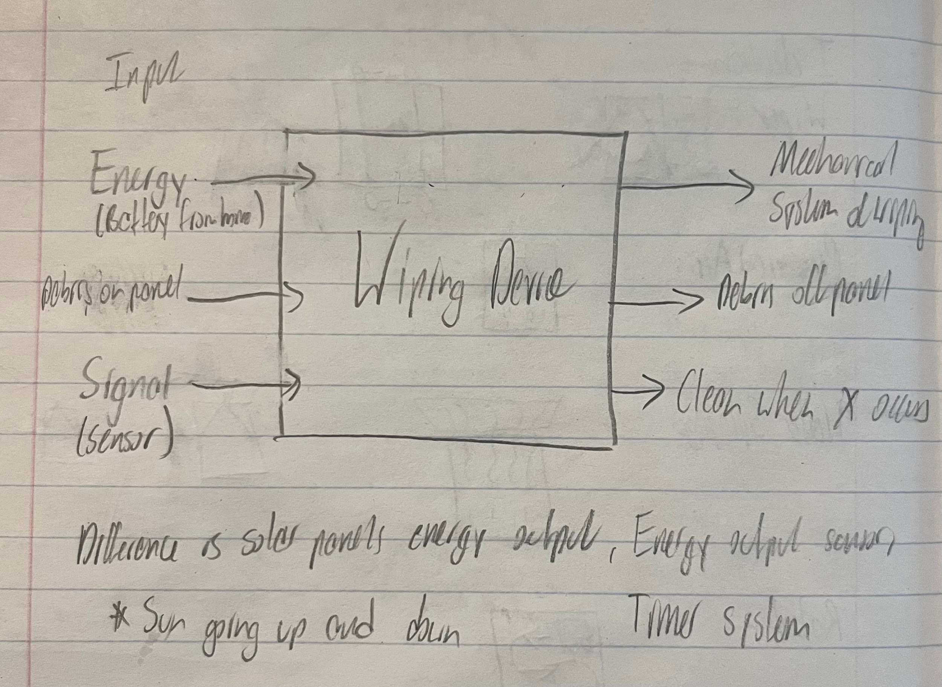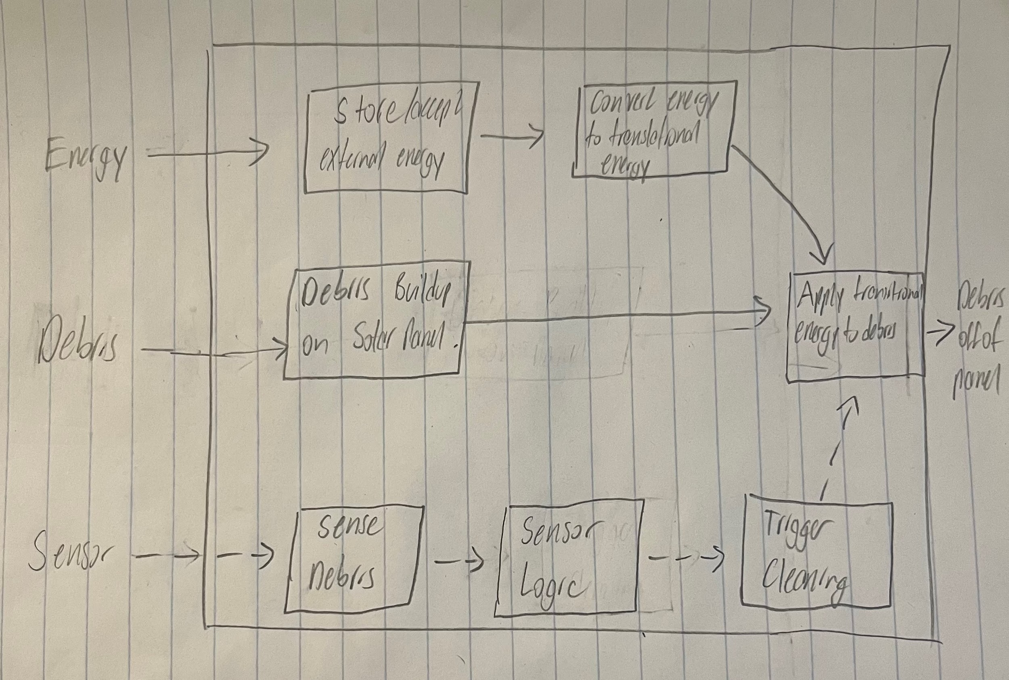

Step 2:

| Competitive Product | Patent Number | Title/Description | Relation to the Project |
| --- | --- | --- | --- |
| Pleco Solar | Based on Bar-Ilan University Patents  Patent Pending? | Robot Solar Panel Cleaner | Concept for brushing debris off  Rotating brush  (robot does not use water) |
| Straight Sweep Windshield Wiper | US4245369A | Wiper arms | Concept for the movement of the wiper |
| iRobot Roomba | US9883783B2 | Debris detection | Concept for detection of when to clean the panel. |

**Pleco Solar (Brushing)**

| Metric | Importance | Score |
| --- | --- | --- |
| No Water Use | 4 | 5 |
| One-Time-Purchase | 5 | 4 |
| Cost | 4 | 1 |
| Easy-to-Use | 4 | 5 |
| Brushing Debris | 5 | 5 |
| Simplicity | 5 | 2 |
| Compatibility with panels | 4 | 4 |

**Straight Sweep Windshield Wiper**

| Metric | Importance | Score |
| --- | --- | --- |
| Motion efficiency | 4 | 4 |
| Long length | 4 | 3 |
| Blades are whole of wiper arm length | 4 | 1 |
| Motor driven arm | 5 | 4 |
| Simple design | 5 | 4 |
| Low cost | 5 | 3 |
| Durability | 5 | 4 |

**Roomba Dirt Detect**

| Metric | Importance | Score |
| --- | --- | --- |
| Doesn’t clog up | 5 | 4 |
| Low cost component | 4 | 3 |
| Piezoelectric sensor | 3 | 5 |
| Durable | 5 | 4 |
| Detects instantaneously rather than build up | 3 | 5 |

Step 3:

Exploring Internally:

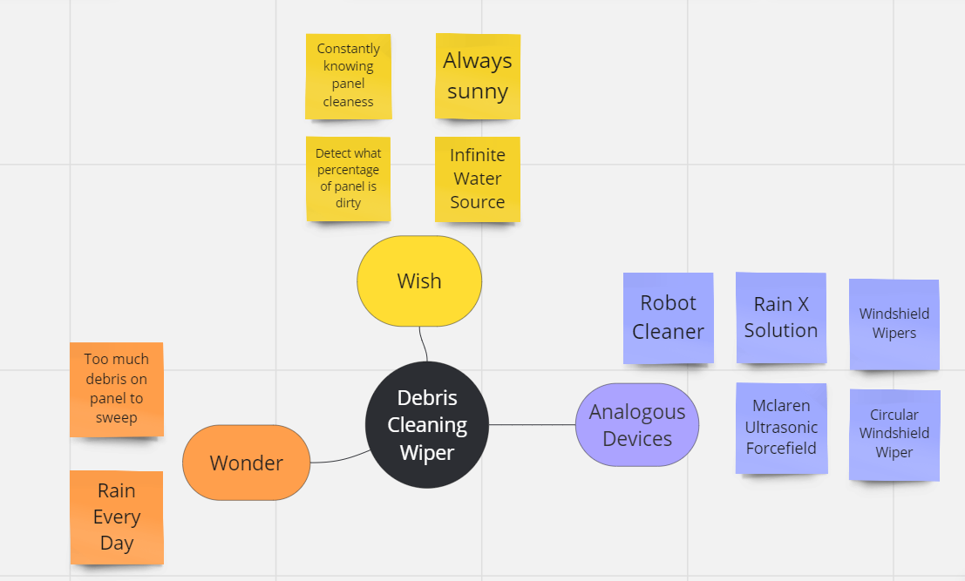

Step 4:

* 1. Explore different methods to perform subfunctions

| Store/Accept External Energy |
| --- |
| Battery |
| Directly from solar panel |
| AC power |

| Triggering/sensing debris |
| --- |
| Scale (Weight) |
| Light detector |
| Solar Efficiency  Timer |
| Manually triggered |

| Apply transitional energy to debris |
| --- |
| Rotational motor connected directly to blade (Windshield) |
| Belt driven pulley system (Horizontal) |
| Air/Water/Other liquids |

* 1. Most promising methods:
     1. Store/Accept External Energy: AC Power from home, Battery
     2. Sense Debris: Timer, Solar Efficiency
     3. Apply transitional energy to debris: Rotational motor connected directly to blade (Windshield wiper), Belt driven pulley system (Horizontal wiper)

| Store/Accept External Energy | Triggering/sensing debris | Apply transitional energy to debris |
| --- | --- | --- |
| AC power | Timer | Rotational motion |
| Battery | Efficiency calculation | Linear motion |

Sketches Below:

**Battery, Solar Efficiency Sensor, Horizontal Motion, Rotating Brush**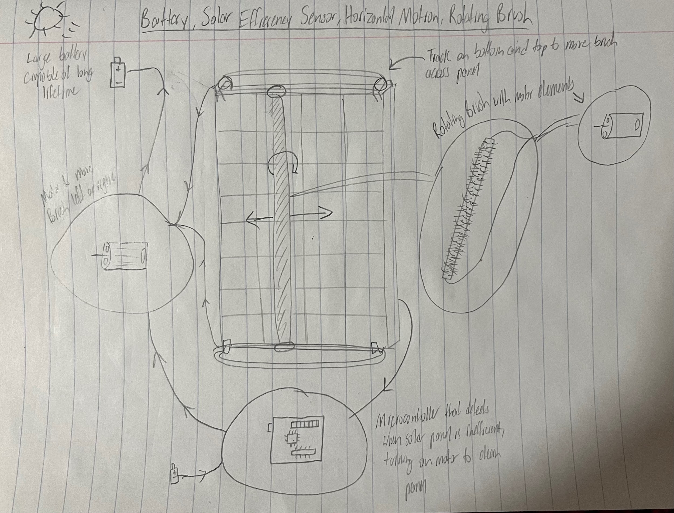

**AC Source, Timer “Sensor”, Rotational Motion, Wiper**

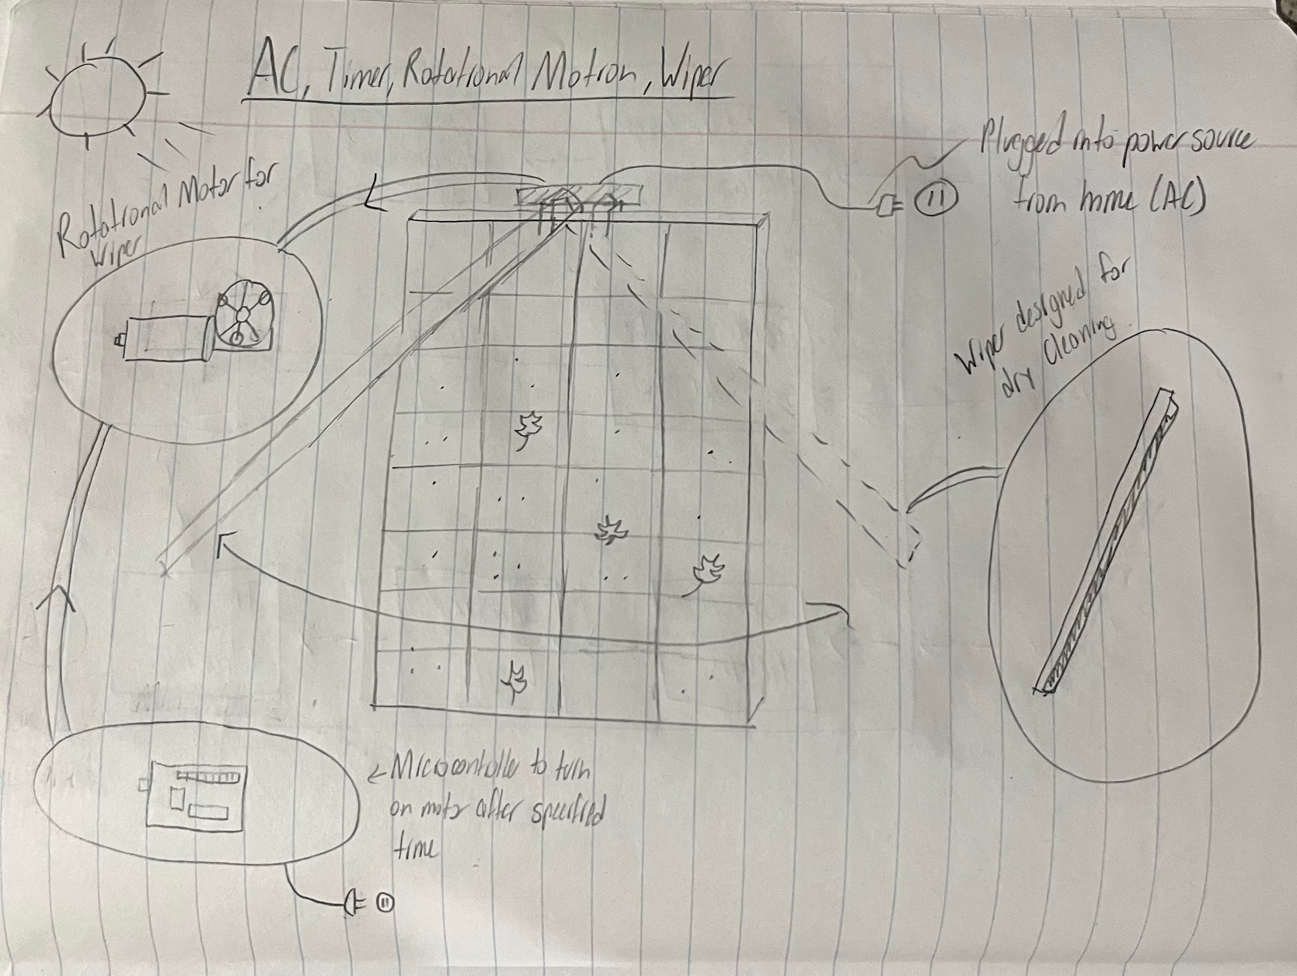

Step 5:

* Is the team developing confidence that the solution space has been fully explored?
  + Yes, we do. We feel that our choices in the sub function exploration were fully fleshed out. We are confident that our systems are well thought out and ready for the next phase of the Ideation Derby.
* Are there alternative function diagrams?
  + Yes, there are alternate ways that you can make these diagrams, but we believe these are the best ways to make these systems.
* Are there alternative ways to decompose the problem?
  + Yes, we could have created other ideation charts that organized our thoughts and collective conception of our device. However, the ways we have used to decompose the problem are efficient in helping us brainstorm and explore our boundaries while journeying towards a solution.
* Have external sources been thoroughly pursued?
  + We have explored several patents and products relating to our designs, picking out some of the highlights of our searches. The external sources, which are cited below, have been explored thoroughly in our opinion, showing similarities to the ideas that we have proposed.
* Have ideas from everyone been accepted and integrated in the process?
  + Everyone has participated and put their thoughts out to the group in order to fully come up with ideas relating to this solution. By accepting each other's inputs, we were able to develop more complete and concrete designs.

Citations (IEEE):

[1] “Product Pleco Solar” Blade Ranger. Accessed February 12, 2024. [Online]. Available: <https://bladeranger.com/pleco/>

[2] “Straight Sweep Windshield Wiper” Google Patents. Accessed February 12, 2024. [Online]. Available: <https://patents.google.com/patent/US4245369A/>

[3] “Debris Sensor for Cleaning Apparatus” Google Patents. Accessed February 12, 2024. [Online]. Available: <https://patents.google.com/patent/US20170202419A1/>